Suraj Singh
Superset ID : 7808362

WEEK 2
Spring Core and Maven

Exercise 1: Configuring a Basic Spring Application
Scenario:
Your company is developing a web application for managing a library. You need to use the Spring Framework to handle the backend operations.

Step1 : Set Up a Spring Project:
  - Create a Maven project named LibraryManagement.
Open Eclipse → File > New > Maven Project
Select:
  - Create a simple project (skip): (tick this)
  - Click Next
Fill in:
  - Group Id: com.library
  - Artifact Id: LibraryManagement
  - Click Finish
A new Maven project named LibraryManagement will be created.
Step2 : Add Spring Core dependencies in the pom.xml file.
Open the pom.xml file and add the following inside:

<dependencies> tag:
xml
Copy code
<dependencies>
<!-- Spring Core -->
<dependency>
<groupId>org.springframework</groupId>
<artifactId>spring-context</artifactId>
<version>5.3.32</version>
</dependency>
</dependencies>
After adding, right-click the project > Maven > Update Project to download dependencies.

Step3 : Create applicationContext.xml Configuration File

- Right-click on src/main/resources > New > Folder > name it resources (if not already there).
- Right-click resources > New > File > name it applicationContext.xml.

<?xml version="1.0" encoding="UTF-8"?>
<beans xmlns="http://www.springframework.org/schema/beans"
xmlns:xsi="http://www.w3.org/2001/XMLSchema-instance"
xsi:schemaLocation="http://www.springframework.org/schema/beans
http://www.springframework.org/schema/beans/spring-beans.xsd">

<!-- Define BookRepository bean -->
<bean id="bookRepository" class="com.library.repository.BookRepository" />

<!-- Define BookService bean and inject BookRepository -->
<bean id="bookService" class="com.library.service.BookService">
<property name="bookRepository" ref="bookRepository" />
</bean>

</beans>

Step 4: Create Service and Repository Classes
➤ BookRepository
- Right-click src/main/java > New > Package > name it com.library.repository.
- Inside it, create a class named BookRepository.
package com.library.repository;

public class BookRepository {
public void saveBook(String title) {
System.out.println("Book '" + title + "' saved to the repository.");
}
}
➤ BookService
- Right-click src/main/java > New > Package > name it com.library.service.
- Inside it, create a class named BookService.
package com.library.service;
import com.library.repository.BookRepository;
public class BookService {
private BookRepository bookRepository;
// Setter for dependency injection
public void setBookRepository(BookRepository bookRepository) {
this.bookRepository = bookRepository;
}
public void addBook(String title) {
bookRepository.saveBook(title);
}
}
Step 5: Create Main Class to Load Spring Context
- Right-click src/main/java > New > Package > name it com.library.main
- Create a class MainApp inside this package:
package com.library.main;
import org.springframework.context.ApplicationContext;
import org.springframework.context.support.ClassPathXmlApplicationContext;

import com.library.service.BookService;
public class MainApp {
public static void main(String[] args) {
ApplicationContext context = new ClassPathXmlApplicationContext("applicationContext.xml");
BookService bookService = (BookService) context.getBean("bookService");
bookService.addBook("The Spring Handbook");
((ClassPathXmlApplicationContext) context).close();
}
}
Step 6: Run the Application
- Right-click MainApp.java > Run As > Java Application
OUTPUT 1 :
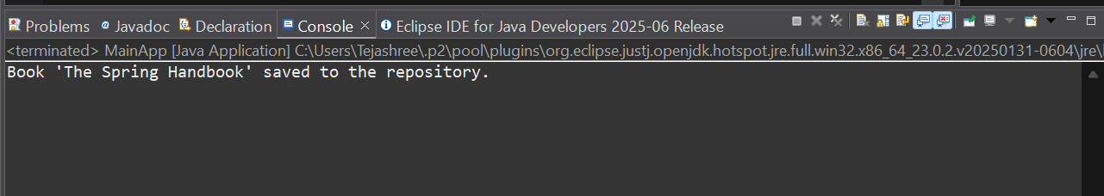

Exercise 2: Implementing Dependency Injection
Scenario:
In the library management application, you need to manage the dependencies between the BookService and BookRepository classes using Spring's IoC and DI.

Step 1:Modifying pom.xml Configuration
- Use the following full pom.xml to add Spring dependency:
<project xmlns="http://maven.apache.org/POM/4.0.0"
xmlns:xsi="http://www.w3.org/2001/XMLSchema-instance"
xsi:schemaLocation="http://maven.apache.org/POM/4.0.0
https://maven.apache.org/xsd/maven-4.0.0.xsd">
<modelVersion>4.0.0</modelVersion>
<groupId>com.library</groupId>
<artifactId>LibraryDIExample</artifactId>
<version>1.0-SNAPSHOT</version>
<properties>
<maven.compiler.source>1.8</maven.compiler.source>
<maven.compiler.target>1.8</maven.compiler.target>
</properties>
<dependencies>
<!-- Spring Core/Context Dependency -->
<dependency>
<groupId>org.springframework</groupId>
<artifactId>spring-context</artifactId>
<version>5.3.32</version>
</dependency>
</dependencies>
</project>
Save and Maven > Update Project after adding dependencies.
Step 2: Updating the Repository Class
- com.library.repository.BookRepository.java
package com.library.repository;
public class BookRepository {
public void displayBooks() {
System.out.println("Returning all books from repository.");
}
}
Step 3: Create the Service Class with a Setter Method
- com.library.service.BookService.java
package com.library.service;
import com.library.repository.BookRepository;
public class BookService {
private BookRepository bookRepository;
public void setBookRepository(BookRepository bookRepository) {
this.bookRepository = bookRepository;
}
public void getBooks() {
System.out.println("Fetching books...");
bookRepository.displayBooks();
}
}
Step 4: Configure Dependency Injection in applicationContext.xml
- src/main/resources/applicationContext.xml
<?xml version="1.0" encoding="UTF-8"?>
<beans xmlns="http://www.springframework.org/schema/beans"
xmlns:xsi="http://www.w3.org/2001/XMLSchema-instance"
xsi:schemaLocation="
http://www.springframework.org/schema/beans
http://www.springframework.org/schema/beans/spring-beans.xsd">

<!-- Define repository bean -->
<bean id="bookRepository" class="com.library.repository.BookRepository" />
<!-- Define service bean and inject repository using setter -->
<bean id="bookService" class="com.library.service.BookService">
<property name="bookRepository" ref="bookRepository" />
</bean>
</beans>
- The property tag matches the setter setBookRepository() in BookService.

Step 5: Create the Main Class to Test the Injection
- com.library.main.LibraryManagementApplication.java
package com.library.main;
import org.springframework.context.ApplicationContext;
import org.springframework.context.support.ClassPathXmlApplicationContext;
import com.library.service.BookService;
public class LibraryManagementApplication {
public static void main(String[] args) {
// Load Spring context from XML
ApplicationContext context = new ClassPathXmlApplicationContext("applicationContext.xml");
// Get the bookService bean
BookService bookService = (BookService) context.getBean("bookService");
// Use the bean
bookService.getBooks();
// Close the context
((ClassPathXmlApplicationContext) context).close();
}
}
Step 6: Run the Application
- Right-click LibraryManagementApplication.java
- Choose: Run As → Java Application

OUTPUT 2 :
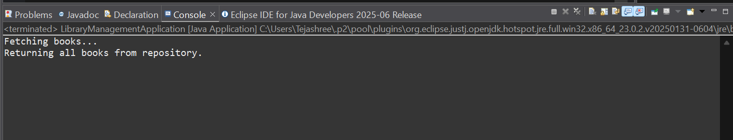

Exercise 4: Creating and Configuring a Maven Project
Scenario:
You need to set up a new Maven project for the library management application and add Spring dependencies.
Step 1: Update the pom.xml to Add Spring Dependencies
- Open the pom.xml file
- Replace the content with the following full working config:
<project xmlns="http://maven.apache.org/POM/4.0.0"
xmlns:xsi="http://www.w3.org/2001/XMLSchema-instance"
xsi:schemaLocation="http://maven.apache.org/POM/4.0.0
https://maven.apache.org/xsd/maven-4.0.0.xsd">
<modelVersion>4.0.0</modelVersion>
<groupId>com.library</groupId>
<artifactId>LibraryManagement</artifactId>
<version>1.0-SNAPSHOT</version>
<properties>
<maven.compiler.source>1.8</maven.compiler.source>
<maven.compiler.target>1.8</maven.compiler.target>
</properties>

<dependencies>
<!-- Spring Context (Core, Beans, Context) -->
<dependency>
<groupId>org.springframework</groupId>
<artifactId>spring-context</artifactId>
<version>5.3.32</version>
</dependency>
<!-- Spring AOP -->
<dependency>
<groupId>org.springframework</groupId>
<artifactId>spring-aop</artifactId>
<version>5.3.32</version>
</dependency>
<!-- Spring Web MVC -->
<dependency>
<groupId>org.springframework</groupId>
<artifactId>spring-webmvc</artifactId>
<version>5.3.32</version>
</dependency>
<!-- (Optional) Servlet API for WebMVC -->
<dependency>
<groupId>javax.servlet</groupId>
<artifactId>javax.servlet-api</artifactId>
<version>4.0.1</version>
<scope>provided</scope>
</dependency>

</dependencies>
<!-- Maven Plugin Configuration -->
<build>
<plugins>
<plugin>
<groupId>org.apache.maven.plugins</groupId>
<artifactId>maven-compiler-plugin</artifactId>
<version>3.8.1</version>
<configuration>
<source>1.8</source>
<target>1.8</target>
</configuration>
</plugin>
</plugins>
</build>
</project>

Step 2: Update Maven
- Save the pom.xml
- Right-click the project → Maven → Update Project…
- Tick your project → Click OK
- Wait for dependencies to download under Maven Dependencies
OUTPUT 4 :
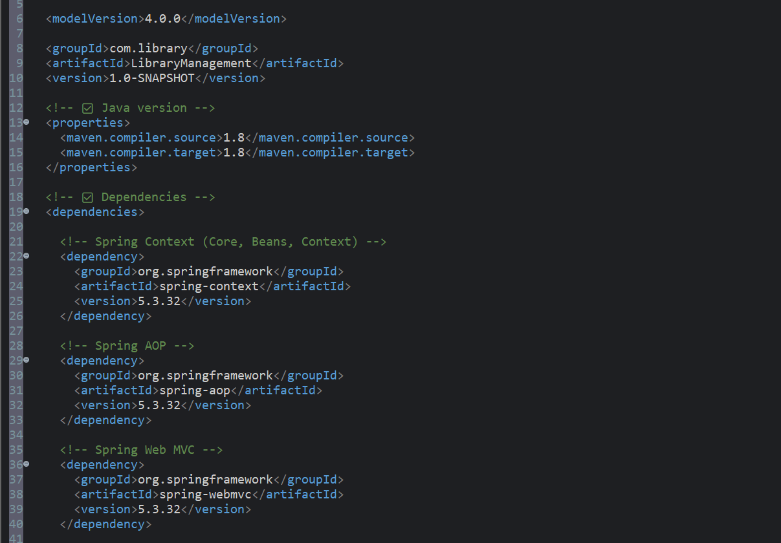

SPRING DATA JPA HANDSON

EX 1 : Difference between JPA, Hibernate and Spring Data JPA

🔹 Java Persistence API (JPA)
- JPA is a specification (JSR 338) for object-relational mapping (ORM).
- It defines the standard interface for persisting, retrieving, and managing Java objects in a relational database.
- JPA does not provide an implementation—instead, vendors like Hibernate implement the JPA standard.
- It defines concepts like Entity, EntityManager, and annotations such as @Entity, @Id, etc.
🔹 Hibernate
- Hibernate is a popular ORM framework and a JPA implementation.
- It allows developers to map Java classes to database tables.
- Developers need to handle session management and transactions manually (unless integrated with Spring).
- It includes both JPA-compliant features and additional non-standard features (like caching and performance optimizations).
Example using Hibernate:

public Integer addEmployee(Employee employee) {
Session session = factory.openSession();
Transaction tx = null;
Integer employeeID = null;

try {
tx = session.beginTransaction();
employeeID = (Integer) session.save(employee);
tx.commit();
} catch (HibernateException e) {
if (tx != null) tx.rollback();
e.printStackTrace();
} finally {
session.close();
}

return employeeID;
}

🔹 Spring Data JPA
- Spring Data JPA is not a JPA implementation.
- Spring Data JPA is a part of the Spring Framework that builds on top of JPA.
- It provides a higher abstraction on top of JPA, reducing boilerplate code.
- It auto-generates repository methods, manages transactions, and integrates tightly with Spring Boot.
Example using Spring Data JPA:
EmployeeRepository.java
public interface EmployeeRepository extends JpaRepository<Employee, Integer> {
}
EmployeeService.java

@Autowired
private EmployeeRepository employeeRepository;

@Transactional
public void addEmployee(Employee employee) {
employeeRepository.save(employee);
}

EX2 : Hands on 1
Spring Data JPA - Quick Example
Software Pre-requisites
- MySQL Server 8.0
- MySQL Workbench 8
- Eclipse IDE for Enterprise Java Developers 2019-03 R
- Maven 3.6.2
Create a Eclipse Project using Spring Initializr
- Go to https://start.spring.io/
- Change Group as “com.cognizant”
- Change Artifact Id as “orm-learn”
- In Options > Description enter "Demo project for Spring Data JPA and Hibernate"
- Click on menu and select "Spring Boot DevTools", "Spring Data JPA" and "MySQL Driver"
- Click Generate and download the project as zip
- Extract the zip in root folder to Eclipse Workspace
- Import the project in Eclipse "File > Import > Maven > Existing Maven Projects > Click Browse and select extracted folder > Finish"
- Create a new schema "ormlearn" in MySQL database. Execute the following commands to open MySQL client and create schema.

Step 1: Create Project from Spring Initializr
- Go to: https://start.spring.io
- Fill the form:
  - Group: com.cognizant
  - Artifact: orm-learn
  - Description: Demo project for Spring Data JPA and Hibernate
- Click "Add Dependencies":
  - Spring Boot DevTools
  - Spring Data JPA
  - MySQL Driver
- Click Generate → it downloads orm-learn.zip

Step 2: Import into Eclipse
- Extract the orm-learn.zip to your workspace.
- In Eclipse:
Go to File → Import → Maven → Existing Maven Projects
- Browse to the extracted folder → Click Finish
Your project is now imported into Eclipse.

Step 3: Create MySQL Schema
- Open terminal/command prompt and run:
mysql -u root -p
- In MySQL client:
create schema ormlearn;

Step 4: Configure application.properties
File: src/main/resources/application.properties
Replace contents with:
properties
# Logging
logging.level.org.springframework=info
logging.level.com.cognizant=debug
logging.level.org.hibernate.SQL=trace
logging.level.org.hibernate.type.descriptor.sql=trace
logging.pattern.console=%d{dd-MM-yy} %d{HH:mm:ss.SSS} %-20.20thread %5p %-25.25logger{25} %25M %4L %m%n

# Database
spring.datasource.driver-class-name=com.mysql.cj.jdbc.Driver
spring.datasource.url=jdbc:mysql://localhost:3306/ormlearn
spring.datasource.username=root
spring.datasource.password=root

# Hibernate
spring.jpa.hibernate.ddl-auto=validate
spring.jpa.properties.hibernate.dialect=org.hibernate.dialect.MySQL5Dialect
Change username and password as per your MySQL setup if needed.

Step 5: Add Logging in OrmLearnApplication.java
File: src/main/java/com/cognizant/ormlearn/OrmLearnApplication.java
Update:
package com.cognizant.ormlearn;
import org.slf4j.Logger;
import org.slf4j.LoggerFactory;
import org.springframework.boot.SpringApplication;
import org.springframework.boot.autoconfigure.SpringBootApplication;
import org.springframework.context.ApplicationContext;

import com.cognizant.ormlearn.model.Country;
import com.cognizant.ormlearn.service.CountryService;

import java.util.List;

@SpringBootApplication
public class OrmLearnApplication {

private static final Logger LOGGER = LoggerFactory.getLogger(OrmLearnApplication.class);
private static CountryService countryService;

public static void main(String[] args) {
ApplicationContext context = SpringApplication.run(OrmLearnApplication.class, args);
countryService = context.getBean(CountryService.class);
testGetAllCountries();
LOGGER.info("Inside main");
}

private static void testGetAllCountries() {
LOGGER.info("Start");
List<Country> countries = countryService.getAllCountries();
LOGGER.debug("countries={}", countries);
LOGGER.info("End");
}
}

Step 6: Create country Table in MySQL
use ormlearn;

create table country (
code varchar(2) primary key,
name varchar(50)
);

insert into country values ('IN', 'India');
insert into country values ('US', 'United States of America');

Step 7: Create the Model Class
- src/main/java/com/cognizant/ormlearn/model/Country.java
package com.cognizant.ormlearn.model;
import javax.persistence.Column;
import javax.persistence.Entity;
import javax.persistence.Id;
import javax.persistence.Table;

@Entity
@Table(name = "country")
public class Country {

@Id
@Column(name = "code")
private String code;

@Column(name = "name")
private String name;

public String getCode() {
return code;
}

public void setCode(String code) {
this.code = code;
}

public String getName() {
return name;
}

public void setName(String name) {
this.name = name;
}

@Override
public String toString() {
return "Country [code=" + code + ", name=" + name + "]";
}
}

Step 8: Create Repository Interface
- src/main/java/com/cognizant/ormlearn/repository/CountryRepository.java
package com.cognizant.ormlearn.repository;

import org.springframework.data.jpa.repository.JpaRepository;
import org.springframework.stereotype.Repository;
import com.cognizant.ormlearn.model.Country;

@Repository
public interface CountryRepository extends JpaRepository<Country, String> {

}

Step 9: Create Service Class
- src/main/java/com/cognizant/ormlearn/service/CountryService.java
package com.cognizant.ormlearn.service;

import java.util.List;

import javax.transaction.Transactional;

import org.springframework.beans.factory.annotation.Autowired;
import org.springframework.stereotype.Service;

import com.cognizant.ormlearn.model.Country;
import com.cognizant.ormlearn.repository.CountryRepository;

@Service
public class CountryService {

@Autowired
private CountryRepository countryRepository;

@Transactional
public List<Country> getAllCountries() {
return countryRepository.findAll();
}
}

Step 10: Build & Run the Application
- Right-click the project > Run As > Maven Clean
- Then: Run As → Maven Build
Set goals to:

clean package
(proxy options are not needed unless you're in a corporate network)
- Finally: Right-click OrmLearnApplication.java → Run As → Java Application

